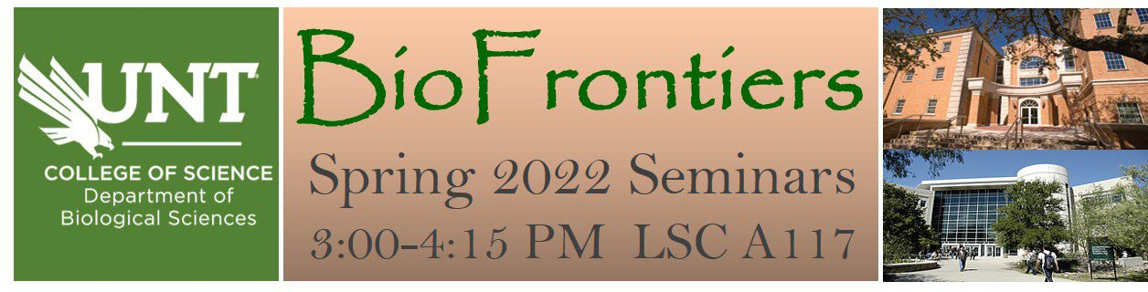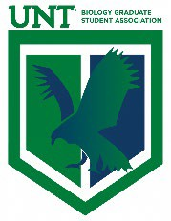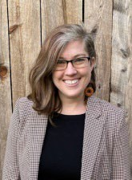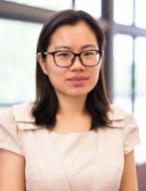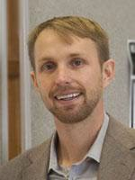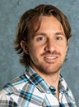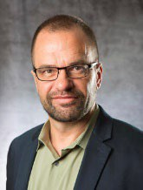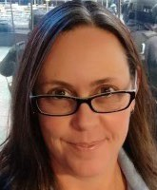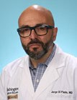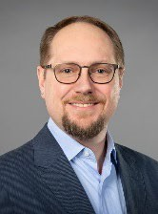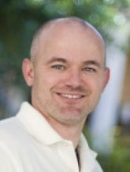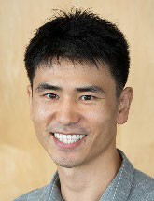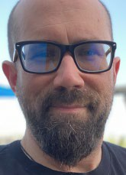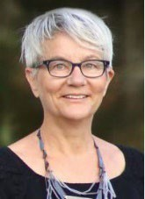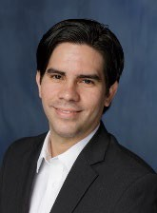
Jan 21: Dr. Vanessa Macias Biological Sciences, University of North Texas Hosted by Dr. Lund

Jan 28: Dr. Lu Liang
Geography and the Environment, University of North Texas
Hosted by Dr. Lund

Feb 4: Dr. Brian Meckes Biomedical Engineering, University of North Texas Hosted by Dr. Shah

Feb 11: Dr. Matt Troia Environmental Science and Ecology, UT San Antonio
Hosted by Dr. Hoeinghaus

Feb 18: Dr. Daniel Voytas
Center for Precision Plant Genomics, University of Minnesota
BioDiscovery Institute Distinguished Speaker
*seminar will be held in ESSC 225

Feb 25: Dr. Meredith Turnbough Scientific Affairs,
Verogen
Hosted by Dr. Dickstein

Mar 4: Dr. Jorge Di Paola
Pediatrics – Hematology & Oncology, Washington University School of Medicine Hosted by Dr. Jagadeeswaran

Mar 11: Dr. Dylan Kosma Biochemistry and Molecular Biology, University of Nevada
Hosted by Dr. Alonso

Mar 25: Dr. Marvin Whiteley Biological Sciences,
Georgia Tech Hosted by Dr. Azad

Apr 1: Dr. Juhyun Lee Bioengineering,
UT Arlington
Hosted by Dr. Mager

Apr 8: Dr. Brett Baker
Marine Science and Integrative Biology, UT Marine Science Institute
Hosted by Dr. Henard

Apr 15: TBD
Biology Research Day Keynote Speaker Hosted by BGSA

Apr 22: Dr. Doris Wagner Biology,
University of Pennsylvania Hosted by Dr. McGarry

Apr 29: Dr. Luis Colon-Perez Pharmacology and Neuroscience, UNT Health Science Center Hosted by Dr. Hoeinghaus

