-webkit-font-smoothing: antialiased;
background-attachment: scroll;
background-clip: border-box;
background-color: rgb(255, 255, 255);
background-image: none;
background-origin: padding-box;
background-size: auto;
box-sizing: border-box;
color: rgb(10, 23, 43);
cursor: auto;
display: block;
font-family: 'Open Sans', sans-serif;
font-size: 16px;
font-style: normal;
font-weight: normal;
height: 521px;
line-height: 24px;
margin-bottom: 0px;
margin-left: 0px;
margin-right: 0px;
margin-top: 0px;
padding-bottom: 0px;
padding-left: 0px;
padding-right: 0px;
padding-top: 0px;
position: relative;
text-rendering: optimizeLegibility;

Chicken embryo in ovo showing extensive CAM vasculature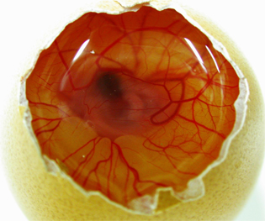
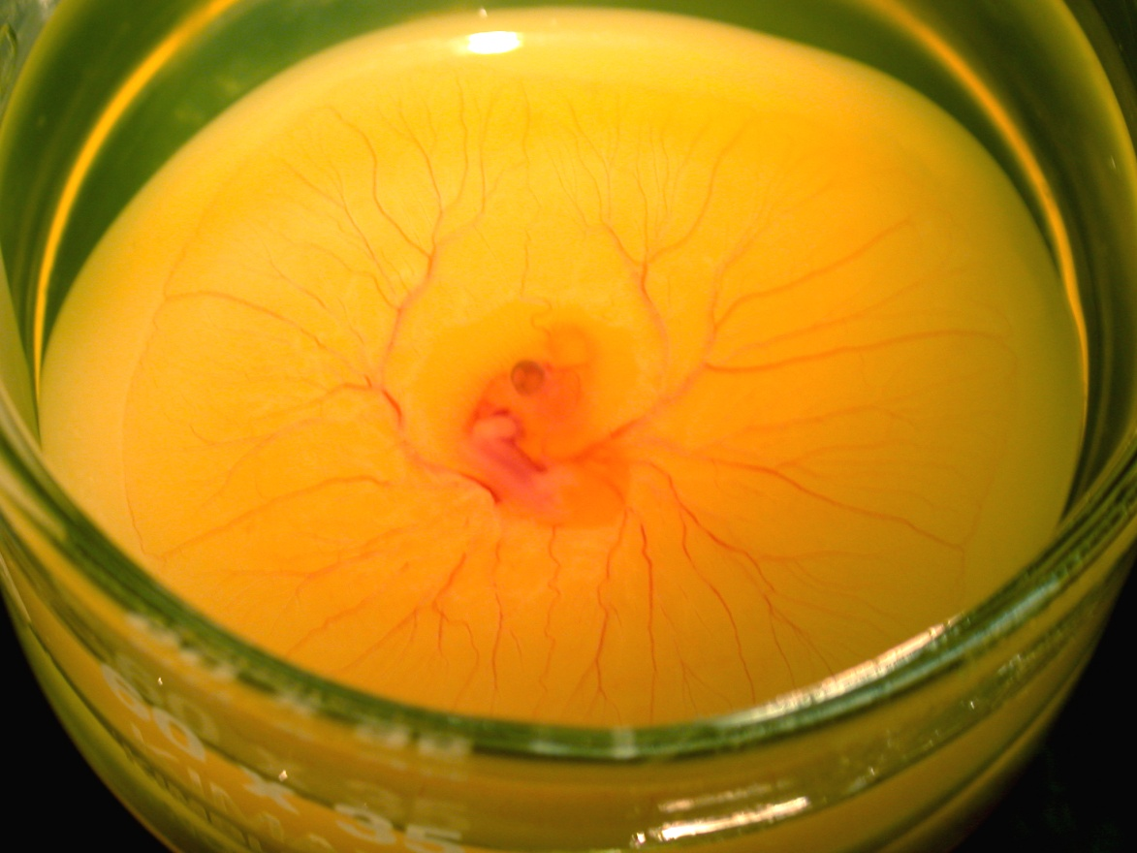
A representative image of shell-less cultured chicken embryo.

. Technique for measuring CAM vessel density index, measurement concentric circles.
Numbers show radius of circles measured (µm).
Vessels intersecting each entire circle were counted to report.
Symbol “C” in the center was used to assure placement of circles was aligned correctly.
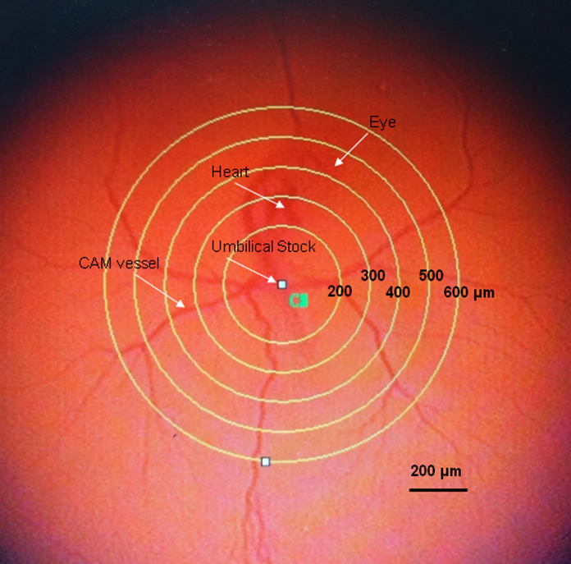

Measurements of (A) Gill arch length; (B) Gill filament length; (C) Secondary lamella length; (D) Secondary lamella width.
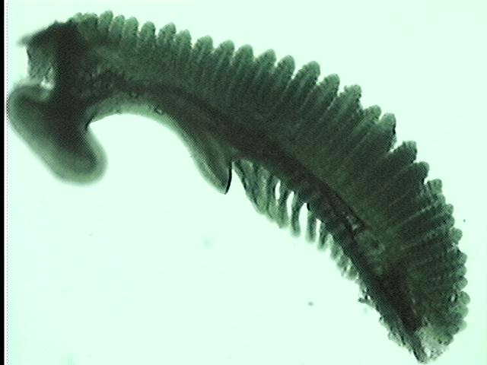
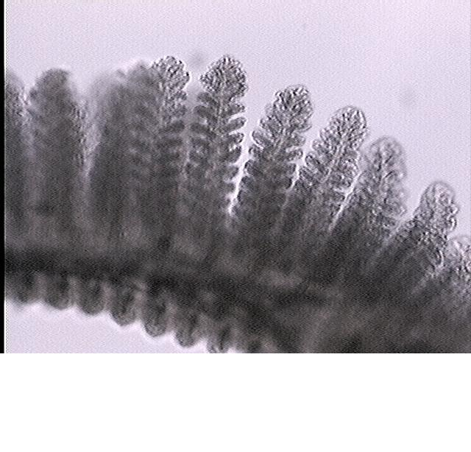
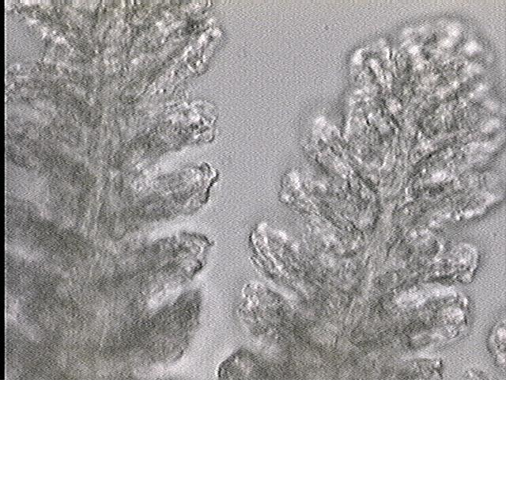
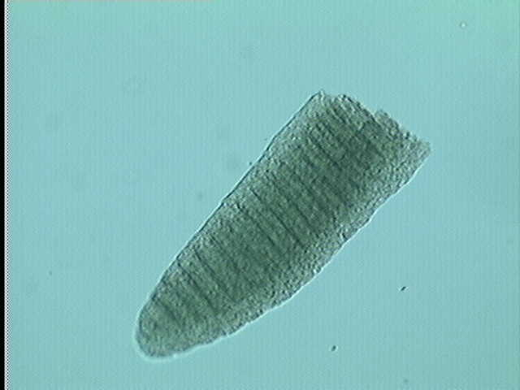
1 mm
0.25 mm
0.1 mm
0.1 mm
B
C
A
D

